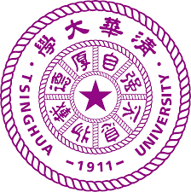


Tsinghua MRC-LMB Symposium

Preliminary Program
9.30 | Welcome
9.35 | Hongwei Wang
10.00 | Manu Hegde
10.25 | Kelly Nguyen
10.50 | Break – coffee and pastries
11.20 | Zhucheng Chen
11.45 | Joe Yeeles
12.10 | 2 Short Talks
12.40 | Lunch - Canteen
14.00 | Songhai Shi
14.25 | LMB speaker
14.50 | 2 Short Talks
15.15 | Break
15.35 | Jianbin Wang
16.00 | Tanmay Bharat
16.25 | Bailong Xiao
16.50 | End

